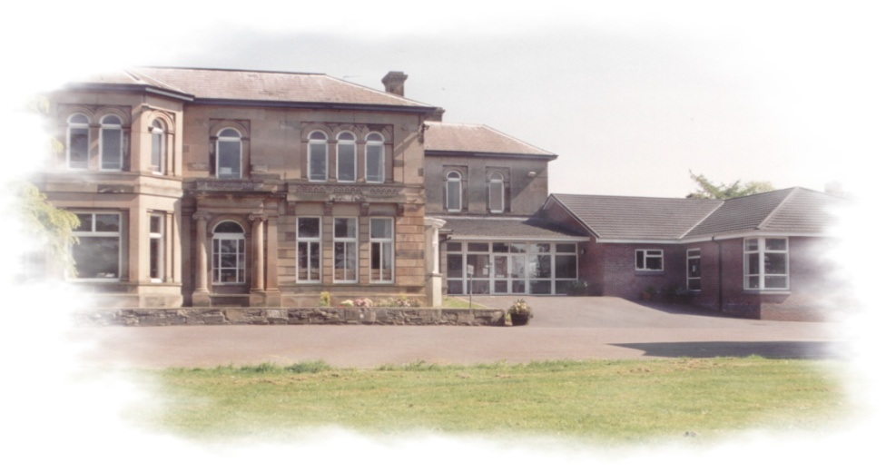

School Prospectus
2023-2024

Mitchell House School
‘Marmont’
Holywood Road
Belfast
BT4 2GT

Tel: 028 9076 8407 or
028 9076 0292
Website: www.mitchellhouseschool.com
E-Mail: info@mitchellhouse.belfast.ni.sch.uk
Facebook: @mitchellhouseschool

Mitchell House is a controlled co-educational school for children aged 3-19 years old which a physical disability and associated learning difficulties.
Welcome

Welcome to Mitchell House School. This booklet will give you information about the aims, values and ethos of our school. The mission statement portrays our belief that what is best for our pupils underpins the decision-making process.

We welcome children, their parents and extended families into a friendly environment where the staff aim to help each pupil reach his/her full potential.

We hope you find the information enclosed beneficial and useful. If you require further information, please contact us at 028 9076 8407. Appointments for visits to school can also be made at this number.

MISSION STATEMENT

At Mitchell House we strive to encourage mutual respect, trust and individuality. It is our goal to nurture learning and help our pupils to achieve their full potential.

THE NORTHERN IRELAND CURRICULUM

Aims to empower young people to achieve their potential and to make informed decisions throughout their lives.

STRATEGIC INTENTS

A highly skilled, highly trained and knowledgeable staff capable of:
Teaching the Northern Ireland Curriculum
Enhancing progress for all pupils
Enabling pupils to reach his/her full potential

Local/Community and regional partnerships enhance Learning and Teaching

ICT enhances all aspects of the school’s work and supports all elements of the school’s mission statement, aims and aspirations

To equip pupils with the skills and/or qualifications to promote life long learning, taking into account their strengths, interests, capabilities and aspirations.

At Mitchell House School we aim to

- provide a happy, safe and supportive environment that promotes the development of the whole pupil;
- promote self confidence, self-esteem and independence;
- provide pupils with the opportunity to study appropriate accreditation at Key Stage 4 and Post 16;
- develop attitudes, values and skills that can be continued and further developed into adult life and which helps pupils to become contributing members to society.

Admission to Mitchell House School

Prospective parents are very welcome to visit the school at any time by making an appointment with the Principal. Mitchell House School caters for pupils with a physical disability and associated learning difficulty from 3 years old, in his/her pre-school year, to 19 years old.

The following are the requirements for admission to Mitchell House School:

- Pupils will have been statemented as having a physical disability as their primary need, although it is recognised that there may be associated additional learning difficulties and medical needs.

- Prior to enrolment, parents/guardians will arrange an appointment to visit the school and meet the Principal. The parents/guardians and the pupil will be given the opportunity to view the facilities within school and meet the teaching and non-teaching staff as well as therapists and school nurse.

- The statementing process must have commenced before the enrolment of any pupil.

The Special Education Department at the Education Authority – Belfast Office manages the availability of places and the current resource provision within Mitchell House School. Any enquiries concerning the admission of pupils and/or their statement of special educational needs should be addressed to the Special Education Officer, Education Authority, Belfast Office, 40 Academy Street, Belfast BT1 2NQ.

All admissions are in accordance with the Regulation & Procedures laid down by Articles 29 – 33 of the Education and Library Order 1986 (NI).

Board of Governors

The Governors are ultimately responsible for the overall management of the school. They are required to meet a minimum of three times each year but in practice meet more often. Some of their duties include:

- The oversight of the curriculum;

- The control of the budget;

- The provision of information to parents;

- The recruitment of staff;

- The maintenance of the premises (shared responsibility with EA);

- Fostering links with the local community and pursuing the objectives of mutual understanding.

Governors of the school:

William Haughan | Education Authority Rep  Chairperson
Diane Eakin | DENI Rep  Vice Chairperson  Health and Well Being
Clair Whiteside | Education Authority Rep  (Cedar Foundation)
Nuala Crolly | Education Authority Rep
Lois Totton | DENI Rep
Vacant Post | Parent Rep
Jonny Collins | Parent Rep  Safeguarding
Deborah Graham | Teacher Rep
Alison Montgomery | Co-opted Member
Miriam Donnan | Secretary  (Non-voting member)

Organisational management of School

Leadership Team

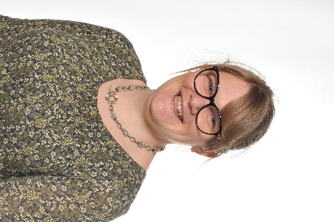

Miss Miriam Donnan Mr Iain Shanks
Principal Acting Vice-Principal

Senior Teachers
Mrs L Boyd
Mrs A Thompson
Miss D Graham

Primary Classes

Class | Teacher/s | Assistants
Ducklings | Mrs Boyd | Ruth Laurie
 | Miss McIlwaine | Jasmin Halliday
 |  | Vacancy
Robins | Miss McCay | Amy Shields
 |  | Kelly Wallace
Toucans | Mrs Collins | Pauline Bell
 |  | Lorraine Walsh
 |  | Rachel Kelly/Vacancy
Swans | Mrs Milligan | Emma Algar
 | Miss Ryan | Vacancy
 |  | Vacancy
Starlings | Miss Wright | Karen Thompson/Vacancy
 |  | Erin Ballentine
 |  | Deborah Moffett
 |  | Vacancy
Penguins | Mr Thompson | Michelle Stewart/Vacancy
 |  | Wendy Halliday
 |  | Vacancy
Puffins | Miss Graham | Kristy Kernohan
 |  | Alex Miskimmin
Sparrows | Mrs Angela Thompson | Ruth Corrie/Vacancy
 |  | Rebekah Ringland
 | General Assistants
 | Foundation | Margaret Boyd/Deirdre McMahon
 | KS1/2 | Zara Lockhart

Post Primary Classes

Class | Teacher/s | Assistants
Kestrels | Mrs Magowan | Diana Fox
 |  | Suzanne Perrott
 |  | Claire Donaghy
Colts | Mrs Alison Thompson | Cathy Walker
 | Vacancy | Deborah Orr
 |  | Vacancy
Jaguars | Mrs Martin | Sarah Henderson/Rachael Cooper
 |  | Jacqui Coey
 |  | Lynda Thompson
 |  | Zoe McGrath
Panthers | Mr Gordon/Mr Kennedy | Wendy Wilson/Vacancy
 |  | Liz Peterson/Vacancy
 |  | Gemma Lucas
Falcons | Mrs Murphy | Samantha Wilgar
 |  | Heather Brownlee/Vacancy
 | General Assistants
 | KS3 | Leanne Lester
 | KS4/Post 16 | Victoria Chazara Gilespie

Senior Clerical Officers: Mrs Alison Millar and Mrs Gill Elliot (Job share)
Clerical Officer: Mrs Trish Hull

Technician: Mr Brian Soley

Building Supervisor: Mr Ken Comfort

Cleaning Supervisor: Vacancy

Cleaning Staff Ms Sonia Laverty, Lisa Ward,
Mr Stan Neidbal and Vacancy

The School Day

PRIMARY DEPARTMENT
Ducklings, Robins and Toucans
9.00am – 2.00pm

Swans, Starlings, Penguins, Sparrows
9.00am – 3.15pm

Break: 10.45am - 11.00am
Lunch: 12.15pm - 1.00pm

POST PRIMARY DEPARTMENT
Form Time* 9.00 – 9.15
Period 1 9.15 – 10.00
Period 2 10.00-10.45

Break 10.45 – 11.00

Period 3 11.00 – 11.45
Period 4 11.45-12.30

Lunch 12.30 – 1.15

Period 5 1.15 – 1.55
Period 6 1.55 – 2.35
Period 7 2.35 – 3.15

*Form time is to enable form teachers to support students socially and emotionally at the beginning of the day.

Pre-School – Nursery (Ducklings)

The Nursery is available to children in their pre-school year following referral by an educational psychologist. There are approximately ten places available.

Individual programmes are devised by a multi-disciplinary team consisting of the class teacher, occupational therapist and speech and language therapist with support from experienced classroom assistants and a general assistant.

A safe, secure and stimulating environment is provided where children are encouraged to interact, develop self-help skills, develop communication skills and develop a curiosity about the world around them.

If you are interested in having a look around our school in order to help you decide on your child’s nursery placement please phone to make an appointment.

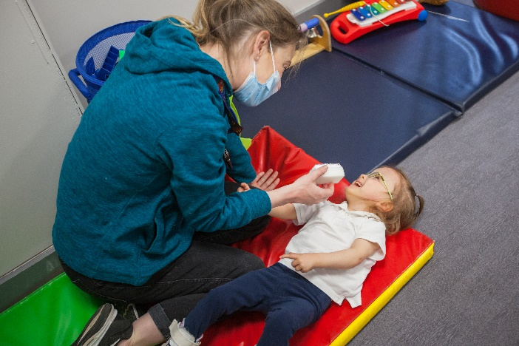
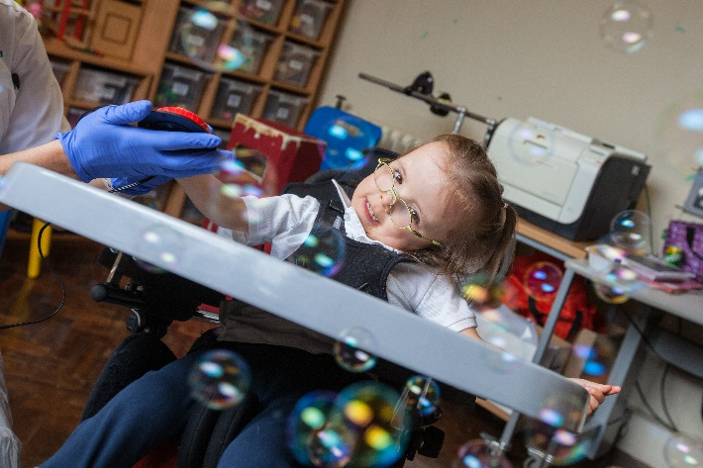
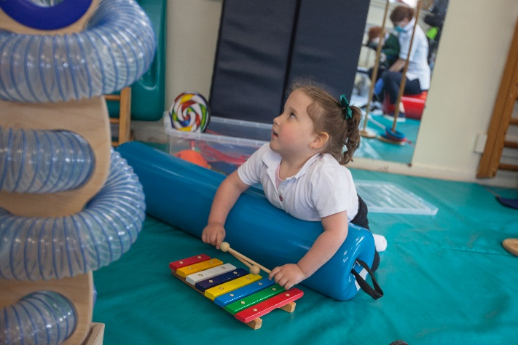
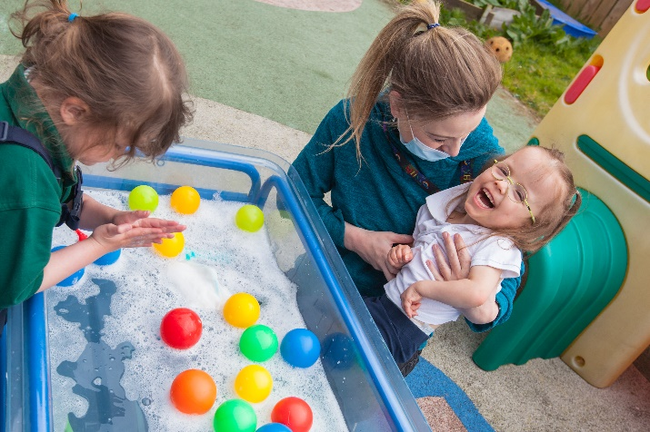
Stages of the Primary Curriculum

The Foundation Stage: Years 1 and 2 (Robins, Toucans)
Key Stage 1: Years 3 and 4 (Swans, Starlings)
Key Stage 2: Years 5, 6 and 7 (Starlings, Sparrows)

The Revised Northern Ireland curriculum

The Northern Ireland curriculum sets out the minimum requirements that should be taught at each stage. Within these requirements, all schools have a responsibility to provide a broad and balanced curriculum for all children.

Mitchell House School aims to give every child the opportunity to experience success in learning and to achieve to the best of his/her ability.

Foundation Stage

Young children come to school from a variety of backgrounds, having had a range of diverse learning experiences at home and at pre-school education. The Foundation Stage aims to build on these learning experiences by providing children with a programme to develop their love of learning. It aims to provide them with the skills they need in school and beyond. Teachers have flexibility in what they teach with the interests of the children playing an important role in the curriculum offered.

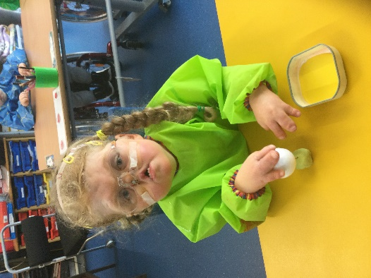
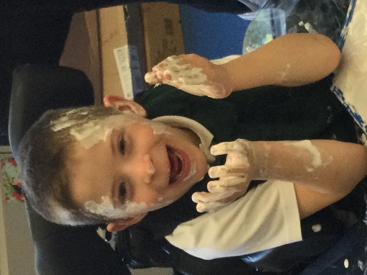
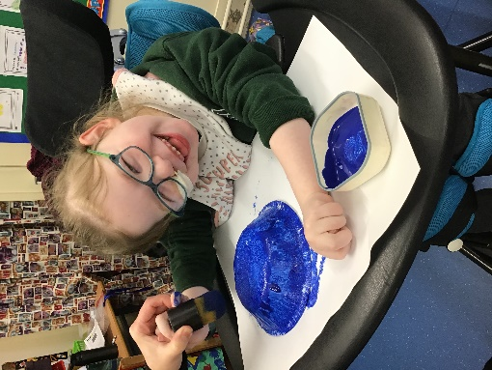
Areas of Learning at Key Stages 1 and 2
The curriculum for Key Stage 1 and 2 is set out in six Areas of Learning comprising:
Language & Literacy  Including Talking and Listening, Reading and Writing. | Mathematics & Numeracy  Including Processes in Mathematics, Number, Measures, Shape and Space and Handling Data. | The Arts  Including Art and Design, Music and Drama.
The World Around Us  Including Interdependence, Place, Movement and Energy and Change Over Time. | Physical Education  Including Athletics, Dance, Games and Gymnastics. | Religious Education  Religious beliefs, practices and values.
Personal Development & Mutual Understanding
Including Personal Development and Health, and Mutual Understanding in the Local and Wider Community.

Stages of the Post Primary Curriculum

Key Stage 3 Years 8, 9 and 10
Key Stage 4 Years 11 and 12
Post 16 Years 13, 14 and 15

The Curriculum at Key Stage 3

All pupils follow the Northern Ireland Curriculum at a level appropriate to their individual needs. Pupils will experience suitable learning activities in the following areas:
- Maths (including Financial Capabilities)
- English
- Science
- Learning for Life and Work (Employability, Citizenship, Personal Development and Home Economics)
- French
- RE
- Environment and Society
- Technology and Design
- Art
- Music
- PE
- Business Studies
- Physical Education

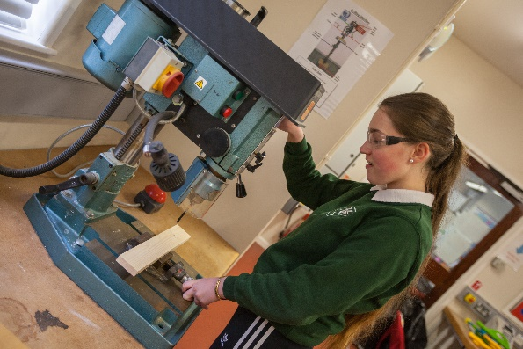
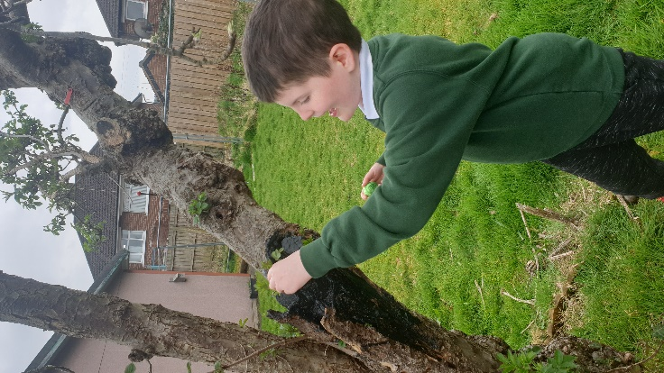
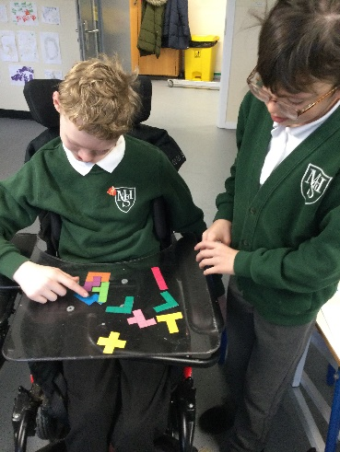

Key Stage 4

At Key Stage 4 the pupils are given the opportunity to follow accredited courses appropriate to their interests and ability.
The subjects we provide at Mitchell House School in Key Stage 4 are as follows with the examination board and level included where it is offered at exam level.

Learning for Life and Work OCR Life and Living Skills
Mathematics CCEA Entry Level 1-3
English CCEA Entry Level 1-3
Science CCEA Entry Level 1-3
Technology and Design CCEA Entry Level 1-3
Geography CCEA Entry Level 1-3 History CCEA Entry Level 1-3
Art and Design CCEA Entry Level 1-3
Performance Skills CCEA Entry Level 1&2
Physical Education CCEA Entry Level 1-3
Religious Education CCEA Entry Level 1-3
Careers Non exam
Occupational Studies CCEA Entry Level 1-3
XL Club Princes Trust

We have a Shared Education programme with Ashfield Boys High School which has led to access to a wider range of subject areas including GCSE qualifications where appropriate and also opportunities to share activities and resources.

We develop skills and capabilities in work related areas to help equip all pupils for life after school. Links have been developed with Careers Officers from DEL, a College of Further Education and local employers to provide the pupils with opportunities to apply skills in a practical situation.

Pupils in Post Primary will be given a homework schedule which they will be expected to follow each week.

Work placement/work experience plays an important part in the school LLW programme.

Extra-Curricular Activities

In addition to the statuary curriculum Mitchell House School provides a wide range of extra-curricular activities and has excellent community links with the local, wider and international community.

Through our extended schools programme we provide after schools clubs one day a week. We incorporate many additional creative activities within school and have useful links with associations such as disability sport and the IFA.

Pupils in Key Stage 2 and 3 have the opportunity to go swimming and others will have a chance to go to the hydro pool and/or horse riding with the physiotherapy team. Foundation stage students have the chance to visit the donkey sanctuary and some of the Post Primary students may have the opportunity to take part in the Duke of Edinburgh Award Scheme.

We have a very enthusiastic school choir who do several performances throughout the year.

The pupils get out on regular educational visits and we also arrange an annual residential outing for our pupils who are transitioning to Post Primary.

We have a summer scheme for 1 week during the summer for the pupils.

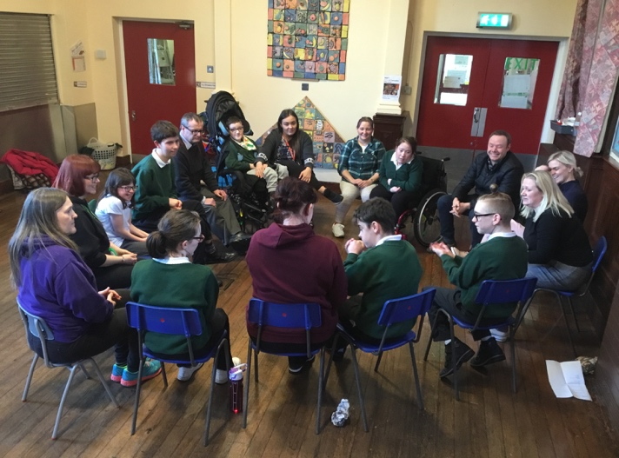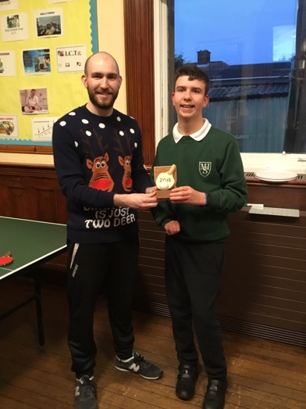

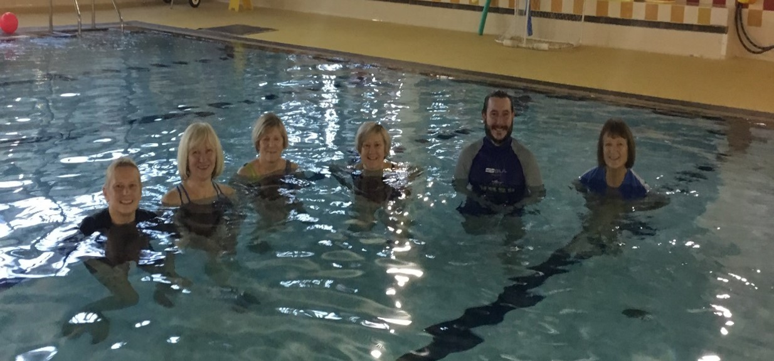
PASTORAL CARE

Mitchell House School is committed to provide a happy, safe and supportive environment that promotes the development of the whole child to help him / her reach his / her full potential.

All members of staff, operating within the Staff Code of Conduct, have a pastoral responsibility towards the pupils in their care and take all reasonable steps to ensure their welfare is safeguarded.

We recognise that it is every child’s right to be heard, listened to and taken seriously and to be consulted.

Students can avail of a school counselling service provided through Family Works and Counselling4Youth.

All Child Protection issues are managed by the Designated Teacher and two Deputy Designated Teachers.

Designated Teacher
Mrs Paula Collins

Deputy Designated Teacher Deputy Designated Teacher
Miss Miriam Donnan Mr Iain Shanks

Speech and Language Therapy

The Speech and Language Therapy Department is staffed by 1 full time, 2 part time Speech and Language Therapist & 1 Speech and Language Therapy assistant.

The Speech and Language Therapists are responsible for the assessment, diagnosis and treatment of a wide range of communication and eating / drinking difficulties.

Following assessment the Speech and Language Therapist may work on one or more of the following areas to enable your child to reach his / her full potential:
- Listening skills
- Understanding
- Putting words together
- Sounds
- Oral skills
- Social skills
- Voice and fluency
- Alternative and augmentative communication systems
- Eating / drinking skills.

Intervention may take the form of one or more of the following:
- Direct therapy either on an individual or group basis
- Class based work
- Joint treatment sessions with Physiotherapy or Occupational Therapy
- A supervised home programme of work
- Review of speech and language skills

Parents are encouraged to play an active role in their child’s treatment programme by attending and participating in treatment sessions, attending training sessions, carrying out therapy activities at home, and meeting with the therapist at annual review.

The Speech and Language Therapy Department recognizes the importance of a holistic approach and of working closely with other therapists, teachers, class room assistants / care staff and parents.

Should you have any questions the Speech and Language Therapy Department in Mitchell House School can be contacted on:

Tel: 028 9076 5911

Physiotherapy

The Physiotherapy staff in Mitchell House School are employees of Belfast Trust and Social Care Trust.

The purpose of the physiotherapy service is to assess and treat children with physical disabilities. We aim to help each child to become as mobile and as independent as is possible for them. Your child’s physiotherapist will use a wide range of treatment approaches which include play, specific activity programmes and possibly hydrotherapy. The children may be treated individually or in groups.

We aim to help your child make the most of his/her abilities and minimise the problems caused by his / her disability.

Should you have any questions the Physio Therapy Department in Mitchell House School can be contacted on:

Tel: 028 9076 5913

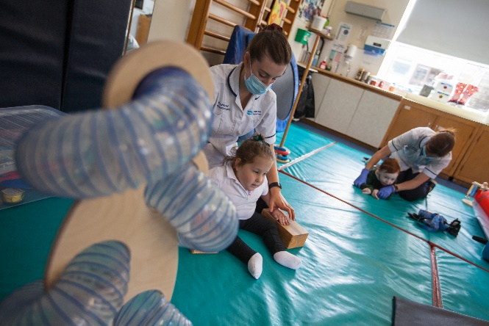

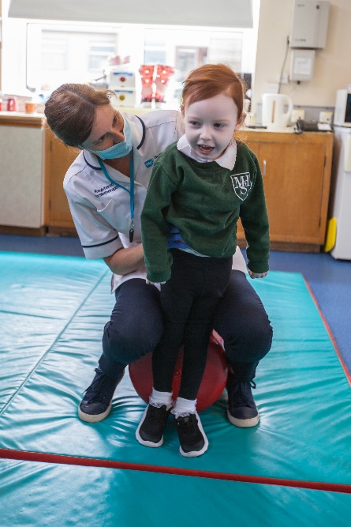

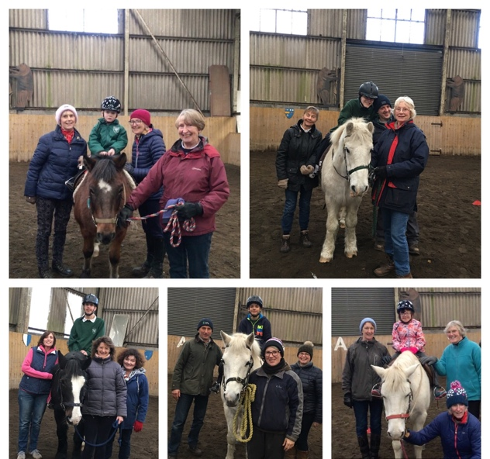
Occupational Therapy

Occupational Therapy is aimed at helping your child be as independent as possible within the school environment.

To help your child Occupational Therapy may include working on:

- sitting posture, through the use of specialized seating and equipment

- hand function, to improve grasp and fine finger movements

- perceptual and cognitive development, to help with concepts of colour, size, shape & body image, concentration and attention

- play skills, to allow younger children opportunities to experience and engage in a variety of play situations

- use of the computer, by means of access devices such as switches, or alternatives to the mouse and keyboard

- personal care skills such as dressing, toileting and feeding

- wheelchair needs, incorporating assessment and provision of wheelchairs, and training in wheelchair skills

- Independent Living Skills, such as basic cookery, shopping, money management, and using community services (public transport, Post Office, bank etc.)

The Occupational Therapist also maintains links with your child’s local community Occupational Therapist regarding equipment and adaptations for the home.

The Occupational Therapist works closely with parents and the educational staff to meet the needs of each child in the best way.

Should you have any questions the Occupational Therapy Department in Mitchell House School can be contacted on:

Tel: 028 9076 5910

Music Therapy

Friends of Mitchell House School provide funding for music therapy which happens one day per week which students access through an in-school referral system.

Nursing Service

We one full time nurse – Marissa Payne, employed by Belfast Health Trust who cater for the students nursing needs during the school day. Should you wish to contact Marissa directly please call 028 9076 5912.

Charging Policy

Article 128, paragraph 2, of the Education Reform (NI) Order 1989 states that all activities provided for pupils within school hours must be free of charge. It also states that any activity directly related to the provision of the Northern Ireland Curriculum or Religious Education must be free of charge.

Charges will not be made for books, practise materials, tuition or transport, which are part of the school curriculum.

Charges will be made for:
1. Board and lodging on residential visits.
2. Activities, agreed to by parents, which take place wholly or mainly outside school hours and are not in order to fulfil statutory requirements in relation to the Northern Ireland Curriculum or to Religious Education.
3. Ingredients, materials or components needed for courses in practical subjects where parents indicate in advance a wish to receive the finished produce.

Voluntary contributions will be sought to support the healthy break and school activities which are not included above.

Pupils will not be treated differently according to whether or not their parents have made a contribution in response to a specific request.

School Transport

At the beginning of each school year parents will be informed by the Transport Department of their Education Authority of the time and place where their child will be collected by the school bus. It is important to stress that these arrangements cannot be changed without prior approval of the relevant branch of the Education Authority. Queries relating to school transport should be addressed to the Education Authority Transport Officer.

School Meals

At present, school meals cost £2.60 per day for pupils in the primary and post primary departments, £2.50 for Nursery pupils only. For this, pupils will have a choice of a main course and pudding, all textures of foods are accommodated in conjunction with Speech and Language Therapy. The school meals meet guidelines set for healthy eating and provide a balanced diet. We request that money for school dinners be sent to school on a Monday.

Free meals are provided to those who are entitled. Details can be obtained from www.eani.org.uk .

If your child requires a special diet, please inform the school in writing as soon as possible so that necessary arrangements can be made.

Mitchell House School is a Healthy Eating School and we encourage all our pupils to make healthy choices. Packed lunches must also be made up of a healthy variety.
Each morning at break time milk is provided free. For a termly contribution, the pupils are offered a healthy fresh fruit snack as well as toast.

All staff in Mitchell House School understand the importance of fresh drinking water and pupils are encouraged to drink water regularly.

School Uniform

The wearing of school uniform is important as it does much to create a sense of unity and equality within the school. The Mitchell House School uniform consists of:
White/green polo shirt
Green sweatshirt (Red sweatshirt for years 14 & 15)
Grey trousers/skirt
or
Grey or black sweat pants

Other items available for purchase include a waterproof coat. The school uniforms can only be purchased from Signature Works Schools (based in Bangor and Belfast) or online at https://www.signatureschools.co.uk/belfast/special-schools/mitchell-house-school/

At Post 16 (Year 13-Year 15) students may opt to wear a red jumper rather than a green.

Grants for Uniform

Under certain circumstances a uniform grant may be available from the Education Authority as are free school meals. Parents should contact the school for further details.

Fund Raising

Friends of Mitchell House School

This group has charitable status and applies for grants to be used to finance programmes that do not fall within education funding. Fund raising has become an essential part of school life.

Projects completed to date include:
- Purchase of a school minibus
- Summer Schemes
- Trips
- Resources for pupils

If you would like further information on the group or could help with fundraising, please contact the school office.

General Information

Individual Education Plans

All pupils have an individual education plan to address their individual educational needs. This is written twice a year by the class/form teacher in consultation with other professionals who are involved with the pupil.

During the parent/teacher consultation which are held in October, parents are given the opportunity to contribute to their child’s IEP.

Annual Review Process

All children in school have an Annual Review. This gives parents and professionals the opportunity to discuss any progress made throughout the year and to ensure the placement at Mitchell House School is the most appropriate as named in the statement of special education needs.

Reports are sent to the parents prior to the meeting and there is an opportunity for parents to contribute to the review.

Parent/Teacher Meeting

Parents (or Guardians) are invited to school during the first term for a parent/teacher meeting. This is an important meeting and informs the parents how well their child is settling into their new class.

Parents of pupils in the Post Primary department have the opportunity to meet their child’s form teacher as well as the subject teachers.

Classroom Assistant Support

Classroom Assistants are employed in classrooms to assist with pupils learning and social needs. They work under the direction of the teacher.

School Visits

To support pupils learning, educational visits are organised to places such as Belfast Zoo, The Ulster Museum, Titanic Centre, W5, The Transport Museum etc. Parents / carers will be informed of the date and planned venue of the outing.

Home/School Links

Pupils in the Nursery and Primary Department have a home/school link book to facilitate communication between parents and staff. Regular contact with school assists both teachers and parents in their roles as joint educators and can be of benefit to enhance pupil learning.

In the Post Primary department, a homework diary informs parents when homework has been set and the completion date. Parents and Carers must inform the school of reasons for absences. There are blue absence notes attached to the school diary for your convenience.

We have a ParentMail system where parents can sign up for e-mail and text communication, so we can keep them better informed. It is beneficial if parents sign up to this service as it reduces our paper and photocopying charges allowing us to spend more money directly on the pupils.

If you have any questions or concerns please do not hesitate to contact Miss Donnan, Principal at any time.
